ICOLabs™ User Manual

Table of Contents

1.0 Introduction | 2
2.0 Definitions | 4
3.0 System Requirements | 7
4.0 Getting Started | 8
5.0 ICOLabs Homepage Navigation | 10
6.0 Global System Behavior | 11
7.0 Standard Reports | 12
7.1 Standard Report and Filter Descriptions | 12
7.1.1 New/Amended Laboratory Results | 12
7.1.2 Selected Laboratory Reports | 16
7.1.3 Subject Results Trend | 22
7.1.4 Study Results Trend | 25
7.1.5 Enrollment Report | 30
7.1.6 Site Activity Report | 32
7.1.7 Specimen Storage Management Report | 35
7.1.8 Kit Inventory Report | 38
7.1.9 General Laboratory Report | 41
7.1.10 Microbiology Laboratory Report | 43
8.0 Custom Searches | 44
9.0 Manage Profile | 45
10.0 Manage Custom Searches | 46
11.0 ICONtrol Panel | 47
11.1 Favorite Reports | 47
11.2 Key Indicators | 47
12.0 Frequently Asked Questions | 49

1.0 Introduction

ICOLabs™ is a web-based remote data access system that provides users near real time remote access to reports and monitoring tools used to view clinical trial laboratory test results, microbiology, specimen storage and kit data. The user has access to protocol specific data for the purpose of viewing on screen, saving as a PDF, printing to paper or exporting into a spreadsheet application. Data presented in ICOLabs are downloaded from ICON Central Laboratories’ primary clinical database every 24 hours and, as such, are not representative of final, cleaned data. Final, cleaned data for clinical analysis are available upon request through the ICON Central Laboratories Data Management Department.

ICOLabs provides the user with 24-hour/7-day per week access to their protocol-specific data. Six major types of information are provided by ICOLabs. These are:

- Laboratory Reports
- Microbiology Reports
- Site Visit Activity Statistics
- Safety Data
- Specimen Storage Status
- Kit Inventory Data

Data are exported on a daily basis from the ICON Central Laboratories’ PACS database to the ICOLabs Oracle database. The data in ICOLabs are near real time, exported on a daily basis.

ICOLabs has been designed to be user-friendly, straightforward, intuitive and reliable. This has been accomplished via a completely web-based system with screen formats that any user can utilize with minimal or no training. Data are presented in various reports that the user can customize by selecting pertinent criteria. The report views and/or custom searches can be saved so the user can access these reports over and over again.

The ICOLabs homepage includes a unique feature called the ICONtrol Panel that enables the user to customize the home page for a specific protocol. The user has the ability to create custom searches and select up to five of these searches as Favorite Reports. The Favorite Reports readily appear on the user’s ICONtrol Panel and can be generated by simply clicking on the appropriate icon. The user also has the ability to select up to four Key Indicators for their protocol. Key Indicators provide study statistics such as the total number of subjects screened, total number of subjects enrolled, total number of active sites and total number of abnormal result flags.

The Standard Reports available in ICOLabs permit the user to review various types of data in a number of different formats. The Standard Reports offer the ability to:

- View a listing of all new and/or amended laboratory and microbiology reports;
- View selected laboratory results;
- Trend laboratory data by subject or study population;
- Review enrollment and site status reports;
- Track kit inventory and kit expiration status;
- Track specimen storage status.
Each report has it’s own report filter page based on the content of the report. Filtering allows the user to select specific criteria before the report is generated, so that the report is customized based on the users needs.
2.0 Definitions

Term | Definition
Abnormal Value | A value that is lower or higher than the established result range for the test, taking into account the subject’s age, sex and other attributes.
Accession Number | The unique order number assigned to tests accompanying the same test requisition.
Alert Values | Values that have been designated to be worthy of telephone notification to the clinical investigator because they fall so significantly outside of the normal range that special care of the study subject may be required.
Amended Report | A report that contains updated information (e.g. collection, demographic or result information). To determine what information has been updated, please refer to the comments section of the lab report.
Analyte | A single test value. Generally, this term is used to refer to a single test value that is reported for a panel of tests.
CLW | Acronym for “Central Laboratory Worksheet,” the comprehensive document used to determine how the trial sponsor wants every aspect of their protocol set up and reported.
Clinical Trial Sponsor | A pharmaceutical or biotechnology company that is conducting a clinical trial.
Collection Date | The date the study subject had their blood drawn and other specimens taken at the investigator site.
Conventional Units | Non-SI units of measure (See SI Units) used in the United States and a few other countries, rather that fully adopting the metric system/ SI units. Although the US mainly uses conventional units for reporting analytes they have adopted SI Units for enzymes and other analyte testing.
Delta Value | A test result value that represents an absolute or percentage level of change (higher or lower) than a previous value for the same test on the same subject in the study. Delta values are established by the clinical trial sponsor to monitor changes in the clinical condition of a single study subject.
Department | A grouping of individual tests that is formally recognized by the laboratory. Panels may be established in recognition of similar processing methods (e.g. a chemistry panel) or because together the tests in the panel provide a comprehensive clinical picture of a particular medical condition (e.g. a thyroid panel).
Exclusions | Test values that are at a level (high or low) that would prohibit a study subject from entering or continuing to participate in the clinical trial.
Expiration Date | The date until which a collection kit may be used. Several kit components have individual expiration dates. The collection kit expiration date is determined by the earliest expiration date of any individual kit component.
Hover | The ability to “mouse over” a particular data field to view additional information.
Investigator | Short for “Clinical Investigator.” Refers to the physician contracted by the clinical trial sponsor to screen, enroll, and manage a study subject as well as document the subject’s clinical condition.
Kit | Refers to the box of specimen collection tubes and materials prepared by ICON Central Laboratories and sent to the site for use in collecting specimens at a subject’s study visit.
Locked | When a subject visit is received with missing or discrepant demographic or collection information, ICON Central Laboratories “locks” the visit from reporting to the site and inclusion in data transmissions to the client. A visit will also be locked if a requested update is being made to any visit or subject. All testing is performed per usual, unless the missing information prevents the proper testing from being performed. Likewise, all panics, exclusions, and other client-defined abnormal values to be called to the sites are triggered and called as per usual, without delay.
PACS | Short for “Protocol Administration Computer System.” PACS is ICON Central Laboratories’ proprietary computer system that provides for the custom setup and management of clinical trials.
Panic Value | A test result that is recognized as being so abnormal that it is cause for immediate notification of the clinical investigator for rapid medical response to the study subject.
Protocol | The written document that provides the specific procedures to be followed, clinical tasks to be performed and the time intervals at which such activities should be completed. The protocol defines the specific laboratory tests that should be performed at each visit in the study.
Reference Range | The range of result values for a particular test that is considered normal for a study subject in a certain age, sex and, in some cases, race category.
Report Date | The date the ICON Central Laboratories result report was generated.
Result | Short for “test result”. Synonymous with “lab value.” The quantitative or qualitative outcome of a test performed by the laboratory.
Screening | The initial study visit at which a potential study subject is considered for participation in a particular clinical trial.
SI Units | An international system of rational and internally consistent units of all types of scientific quantities. This international system of units is known as SI for its French name, Système International d'Unités. These units are used for many analytes regardless of study/ lab origin, but this metric system has not been widely adopted by the United States and a few other countries for measuring all analytes’ units.
Site | Short for “Clinical Investigator Site.” The location at which the physician participating in the clinical trial works and sees study subjects.
Site ID | The number assigned to a specific site to distinguish it from another site location in the study.
Sponsor | Short for “Clinical Trial Sponsor,” this term refers to the specific pharmaceutical or biotechnology company responsible for the clinical development of the new drug.
Study | Short for “Clinical Study.” Refers to all of the activities that occur as the clinical protocol is conducted.
Subject | Short for “Study Subject.” The term given to individuals who participate in clinical trials. This term is preferable to “patient” when the individual is participating in a clinical trial.
Subject ID | The unique identifier assigned by the trial sponsor to a study subject. This identifier typically has the same format for all study participants and may be numeric or alphanumeric. Clinical trials do not permit the use of study subject names, so the Patient ID is critical in appropriate tracking of study data.
Test | The diagnostic activity performed by the laboratory that renders a clinical result for diagnosis or clinical monitoring purposes.
Unscheduled Visit | A visit completed by the study subject that was not a standard visit anticipated in the clinical protocol. Unscheduled visits are usually conducted if there is reason to be concerned about the subject’s clinical condition, thereby justifying the need for additional testing and monitoring.
Visit Name | Refers to the formal label given to a specific study visit in a clinical protocol to better describe that visit. For example, “enrollment visit” or “dosing visit.” The visit name may also represent a particular time point in the study such as “Week 2.”
Visit Number | The sequence number applied to a visit in a clinical protocol, such as Visit 1, Visit 2, etc. These represent the chronological order in which the study visits occur.

3.0 System Requirements

ICOLabs has been designed so that an approved user can access ICOLabs via any web browser, without additional applications being installed on the client’s PC. The following requirements are recommended for best performance:

Windows
- A PC with a Pentium®-class processor recommended (266 MHz or greater)
- Microsoft Windows® 98 or later (Windows ME, NT 4.0, 2000, XP)
- A minimum of 128 MB of RAM
- Monitors should support 800 X 600 or greater resolution with at least 256 colors.
- Internet Explorer® 5.5 or above. (Other web browsers are compatible with ICOLabs; however Internet Explorer works optimally.)

Macintosh
- An Apple Macintosh® computer with a Power Macintosh or G3/G4 (266 MHz or greater) processor.
- System OS 8.6 or later
- Minimum of 128 MB of RAM.
- Internet Explorer 5.5 or above. (Other web browsers are compatible with ICOLabs, however Internet Explorer works optimally)

NOTE: Pop-Up blocker software must be configured to allow Pop-Ups from the ICOLabs website. Failure to do so will result in reports being blocked from view.

4.0 Getting Started

Access to the ICOLabs system is granted upon receipt of the ICOLabs CLW.

NOTE: Please contact your ICON Central Laboratories Project Manager for any questions regarding the setup of studies or users in the ICOLabs system.

When the setup of the user account is complete, the ICON Remote Data Access Services Department (RDAS) will notify the user with their account information via email. The email will contain a Word document containing the user name, temporary password and URL link to ICOLabs.

Logging Into the ICOLabs System

First Time ICOLabs Users:

- Log into ICOLabs using the following URL: https://rda.icolabs.com. Alternatively, you may log into the system from the ICON Central Laboratories corporate website at www.icolabs.com.

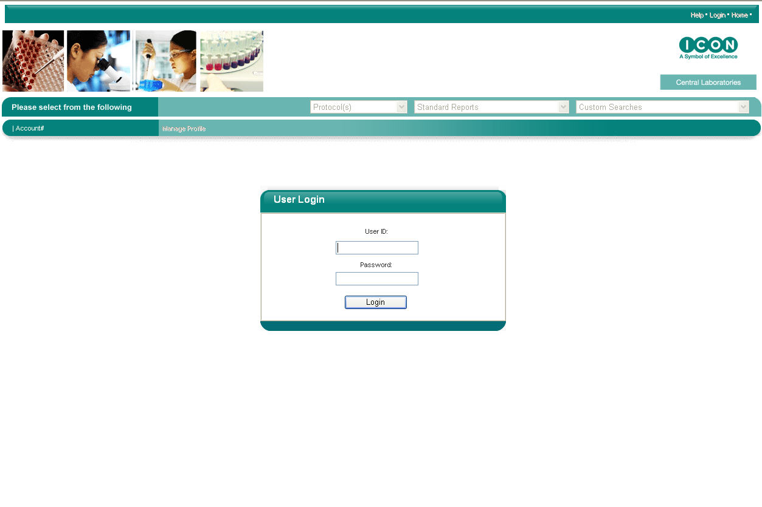

Figure A – User Login Screen

- At the User Login prompt (Figure A), enter the username and temporary password that was provided to you by the ICON RDAS Department.
- The system will prompt you to enter and confirm a new password.

NOTE: The password must be at least 8 alphanumeric characters. Passwords may not be reused and are required to change every 120 days.

- Upon successful change of password, the Terms and Conditions screen will appear.
- To accept the Terms and Conditions, click on Accept. Failure to accept the Terms and Conditions will prohibit the use of ICOLabs.
- Once accepted, the ICOLabs home page, ICONtrol Panel, will appear.

Returning ICOLabs Users:

- Log into ICOLabs using the following URL: https://rcs.icolabs.com
- At the User Login prompt, enter your username and password.

NOTE: Three unsuccessful login attempts will lock the user account. Please contact the ICON RDAS Department to unlock your account and reset your password.

- Upon successful login, the ICOLabs home page, ICONtrol Panel, will appear.

5.0 ICOLabs Homepage Navigation

When you have successfully logged into the ICOLabs application, the homepage will display. To activate the ICONtrol Panel (Figure B), and/or to view reports for your protocol, you must select the protocol that you would like to work with from the Please Select Protocol dropdown bar If only one protocol is assigned, the ICONtrol Panel will default to the assigned protocol. Once a protocol is selected, the ICONtrol Panel will activate with your Favorite Reports, Key Indicators and the Standard Reports listings. The Standard Reports dropdown bar will populate with standard reports. The Custom Searches dropdown bar will populate with any custom searches that you have created for the selected protocol. (Please refer to Custom Searches in Section 8.0 for instructions on setting up custom searches.)

The toolbar located beneath the Protocol Selection, Standard Reports and Custom Searches bar is the User Account toolbar. This toolbar displays the User’s full name and Account #. The Manage Profile link opens the User Maintenance screen. (Please refer to Manage Profile in Section 9.0.) The Manage Custom Searches link opens the Manage Custom Searches screen.

Located in the top right and the bottom center of the screen are links to Help, Logout and Home. Clicking on the Help link will generate the User Manual. When clicking on the Logout link, the system will log you out of the system. A warning message will redisplay, requesting that all active windows must be closed out. The Logout function will log the user out of the main ICOLabs page or Filter page. Clicking on the Home link will generate the ICOLabs home page and will maintain the protocol that you have previously selected.

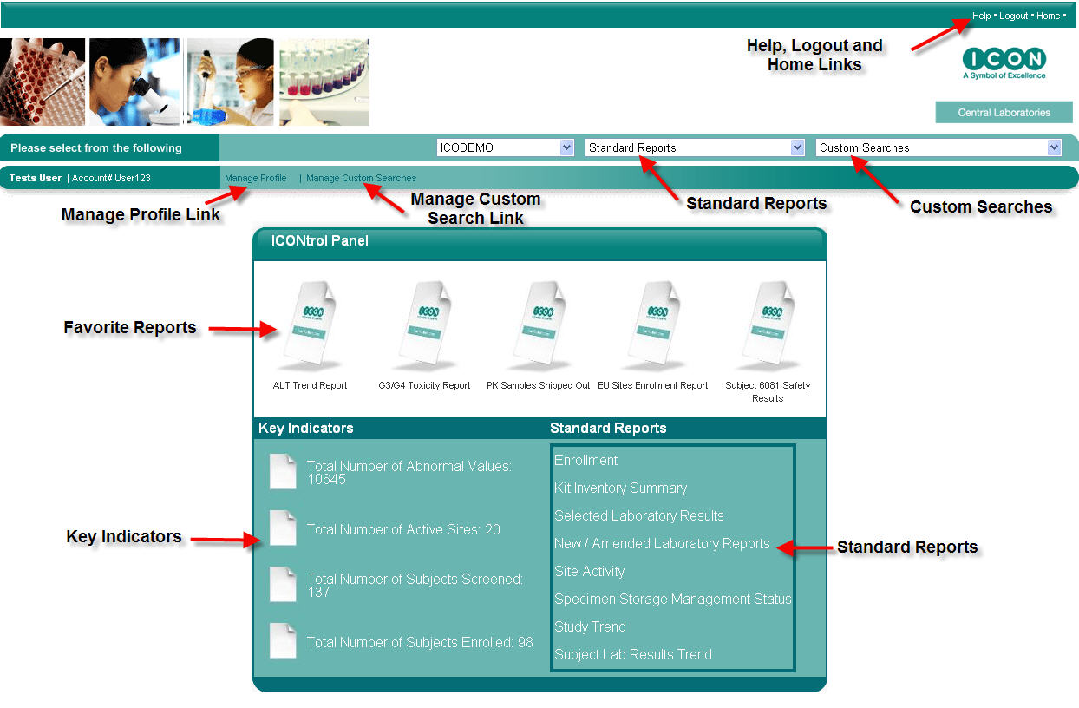
Figure B – The ICONtrol Panel

6.0 Global System Behavior

The user can accomplish the following tasks from the ICONtrol Panel or Filter page:
- Change protocols
- Select Standard Reports
- Select Custom Searches.
- Access the homepage and the ICONtrol Panel by clicking on Home
- Log out of the system by clicking on the Logout link. Please note that it is the responsibility of the user to close all open report windows prior to logging out of the system.
- Access the online user manual by clicking on Help

The user can accomplish the following tasks from the Report output pages:
- Save or Print reports by clicking on the Print link.
- Export reports to a tab-limited .csv Microsoft Excel® file by clicking on the Export link.

Please note the following potential data access restrictions when viewing reports:
- If the subject visit is locked, the word “LOCKED” will appear in place of Test Result. The Units, Result Flags, and any associated comments will be blank. When the visit becomes unlocked, the result data will become available to view online.
- If the user is blinded to specific test(s), the word “BLINDED” will appear in place of the Test Result, Result Flags, and any associated comment.

Please note that the system is designed to timeout after 30 minutes of inactivity. When this occurs, all report windows will become inactive and a message will appear stating that the session has timed out. Clicking the Return to Login button will generate the ICOLabs Login web page. An attempt to access the inactive report page will display a “Session not Active” message, clicking OK will close the report page.

7.0 Standard Reports

ICOLabs includes an extensive suite of standard reports that can be used to access General Laboratory and Microbiology reports, view selected lab results, view and graph trends, view subject status and enrollment reports, view specimen storage data and kit inventory reports.

To generate a standard report, select the report from the Standard Report dropdown menu or choose the report from the ICONtrol Panel.

Once the report has been selected, the filter screen for that report will generate. Filtering allows the user to view specific information within a report. Each report has its own filtering capability, based on the report content and the protocol-specific parameters that were established at the time of the study’s setup. (See Figures E and F)

7.1 Standard Report and Filter Descriptions

7.1.1 New/Amended Laboratory Results

New/Amended Laboratory Results Filter Page
  - Site Criteria – Investigator(s)
By default, all Investigators are listed alphabetically by last name then by first name and credentials. To sort by Investigator Number, click on List by Number. The default sort is ascending. To sort in descending order, click on Sort Desc. If a specific selection is not made, the report will default to include all Investigators. To view specific Investigator(s), highlight the Investigator(s) and then click on the down arrow to select the highlighted Investigator(s). Once the Investigator(s) populate in the Selected box, the Site(s) box will populate with the corresponding Site Numbers associated with the selected Investigator(s).
- Site Criteria – Site(s)
The default sort for sites is in ascending alphanumeric order. To sort in descending order, click on Sort Desc. If a specific selection is not made, the report will default to include all Sites. To view a specific Site(s), highlight the Site(s), and then click on the down arrow to select the highlighted Site(s). Once the Site(s) populate in the Selected box, the Investigator(s) box will populate with the corresponding Investigator Numbers associated with the selected Site(s).
- Test Criteria – Units of Measure
By default, Conventional Units are the units of measure that will display on the screen and on reports. To change the units of measure to Standard International (SI) units, click on the SI Units button.
- Sort By
The Sort By filter option allows the user to select how the report will be sorted. By default, the report is sorted in ascending order by Investigator, then by Subject ID and chronologically by Visit Name. To change the sort order, click on the down arrow and select the field to sort by. Click the appropriate Ascending or Descending button to sort the selected field.

Once the filter selections have been made, click on the Show Report button to generate the report. Clicking on Show Report without making any filter selections will result in generating all new and/or amended laboratory reports.

To make any changes to the filter selections that were chosen, use the Reset button to reset all of the filter choices that were previously selected. To deselect specific filter choices, use the up arrows to remove the selections, uncheck checked selections, or use the “Ctrl” key and click on the values that you want to deselect.

- New/Amended Laboratory Results Report Description
The New/Amended Laboratory Results Report (Figure D) displays a summary listing of all new/amended General Laboratory and/or Microbiology reports that the user has not reviewed or has not marked as reviewed. The user has the ability to view the General Lab and/or Micro reports by using the built in drill down capability. The user can choose to mark reports as reviewed so that the reports will be cleared from the report queue, or the user can not mark the reports as reviewed, causing the reports to remain in the queue.

The following will trigger an amended report:
- Pending results that have been released
- Modified test results (with the exception of a deleted test result)
- Additional test results
- Added, modified, and/or deleted test specific comments

This report includes the following fields, as displayed in Figure C:
- Investigator Name
- Site #
- Subject ID
- Subject Initials
- Collection Date
- Visit Name
- General Lab Accession #
- Micro Accession #
- Flagged Results

This report will list all subjects that have a new and/or amended general laboratory and/or microbiology report. The Flagged Results column will display a ‘Y’ or ‘N’. If ‘Y’ is displayed then one or more of that subject’s results for the subject visit was out of normal range. If ‘N’ is displayed then all results for that subject visit are within normal range.

To sort the report, click on the Ascending or Descending button and then click a column in the report.

To view a different page on the report, click on the appropriate page number. Page numbers are located at the bottom of the report.

Hovering Capability
This report has hover capability on the following fields:
- Investigator Name - Displays the investigator name, the investigator address and telephone number
- Site # - Displays the shipping address
- Subject ID - Displays the subject ID, subject screen ID, subject initials, gender, date of birth and the race code (If applicable)

Drill Down Capability
This report has drill down capability when clicking on the General Lab Accession # or the Micro Accession #. Clicking on one of these fields will generate the General Laboratory or Microbiology Report. (Please refer to the General Laboratory and Microbiology Sections in 7.1.9 and 7.1.10 for report descriptions.)

Marking Reports as Reviewed
To mark a report as reviewed, click the box in the Clear Lab Report(s) column, next to the report reviewed. When all reports that have been reviewed have been marked (Figure C), click on Clear to remove the reports from the queue.

NOTE: Clicking on the Clear button removes a report from the queue, regardless of whether the General Laboratory and/or Microbiology report was reviewed. If the row contains both General Lab and Micro reports, both will be cleared from the queue and marked as reviewed.

To mark all reports that are displayed on the page as reviewed, click on Select All Lab Reports and then click on Clear to remove the reports from the queue.

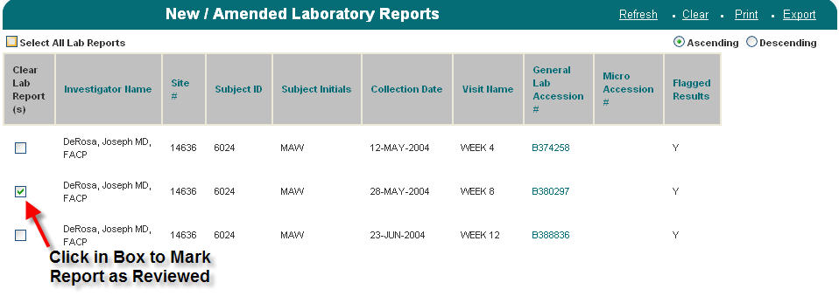
Figure C – Marking the New/Amended Reports as Reviewed

General Laboratory and/or Microbiology reports can also be marked as reviewed when reviewing the report, itself. Please refer to General Laboratory and Microbiology Reports in section 7.1.9 & 7.1.10 for report description.

Refresh
Clicking on Refresh will refresh the screen and update the queue and the report to reflect any reports that were marked as reviewed. Upon marking a report as viewed through the General and/or Microbiology Report and returning to the report page, clicking Refresh will remove these reports from the report page.

Print
Clicking on Print will generate the Print Preview page of the report. From this screen, clicking on the Printer icon will generate the Print dialog box. The report can also be saved as a PDF document from this screen by clicking on the Save icon.

Clear
Clicking on Clear will remove all reports checked off as reviewed from the queue and refresh the page to reflect the queue.

Export
Clicking on Export will open the File Download dialog box. The file can be opened or saved as a Microsoft Excel® comma separated file. If Open is chosen, without saving the report, Microsoft Excel® will auto format the report text. To keep the format the same, choose to Save the report as a .csv file and then import the .csv file into any spreadsheet application.

Your Filter Criteria
The box entitled Your Filter Criteria contains the filter criteria that were selected when the report generated.

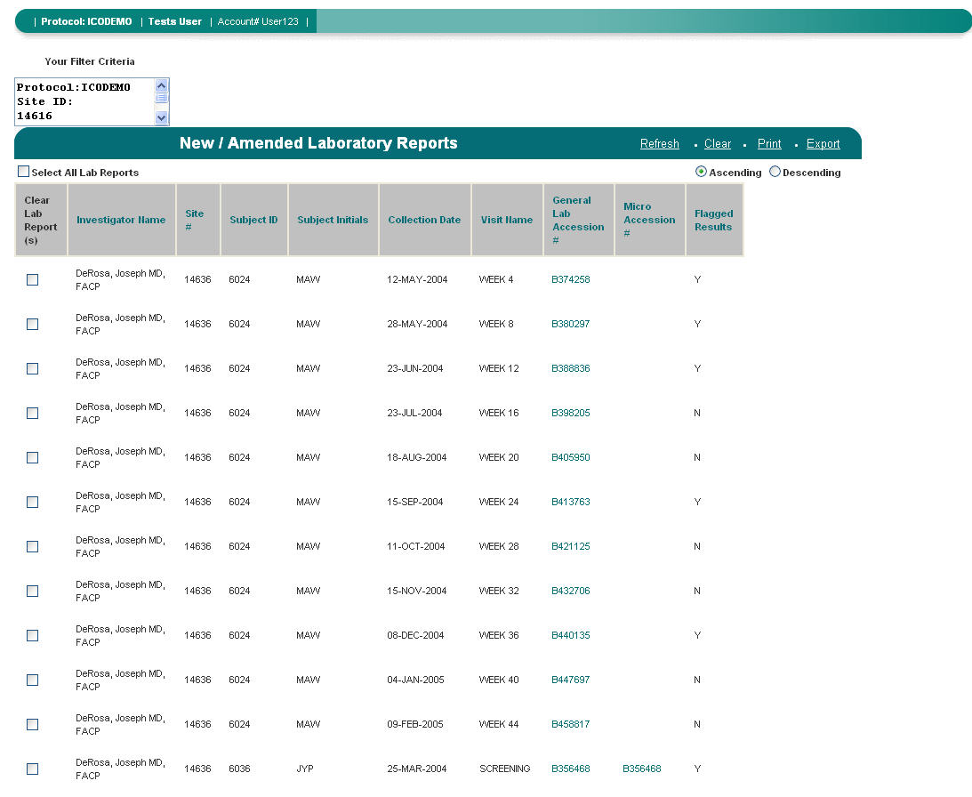
Figure D – New and Amended Laboratory Results

7.1.2 Selected Laboratory Results

- Selected Laboratory Results Filter Page (Figure E & F)
  - Site Criteria – Investigator(s)
By default, all Investigators are listed alphabetically by last name then by first name and credentials. To sort by Investigator Number, click on List by Number. The default sort is ascending. To sort in descending order, click on Sort Desc. If a specific selection is not made, the report will default to include all Investigators. To view specific Investigator(s), highlight the Investigator(s) and then click on the down arrow to select the highlighted Investigator(s). Once the Investigator(s) populate in the Selected box, the Site(s) box will populate with the corresponding Site Numbers associated with the selected Investigator(s).
- Site Criteria – Site(s)
The default sort for sites is in ascending alphanumeric order. To sort in descending order, click on Sort Desc. If a specific selection is not made, the report will default to include all Sites. To view a specific Site(s), highlight the Site(s), and then click on the down arrow to select the highlighted Site(s). Once the Site(s) populate in the Selected box, the Investigator(s) box will populate with the corresponding Investigator Numbers associated with the selected Site(s).
  - Subject Criteria – Subject ID(s)
By default, all Subject IDs are listed alphabetically by Subject Initials – Subject ID. To sort by Subject ID click on List by Number. The default sort is ascending. To sort in descending order, click on Sort Desc. If a selection is not made, the report will default to include all Investigators. To view specific Subject(s), highlight the Subject ID(s), and then click on the down arrow.
  - Subject Criteria – Birth Date
Enter a range of Birth Dates in DD-MMM-YYYY format in the FROM and TO fields.
  - Subject Criteria – Gender (If applicable)
By default, both Male and Female are selected. To view only Male subjects, uncheck the Female checkbox. To view only Female subjects, uncheck the Male checkbox.
  - Subject Criteria – Race Code(s) (If applicable)
By default, all race codes are selected. To view specific race code(s), select the Race Code(s) by clicking on the appropriate Race Code.

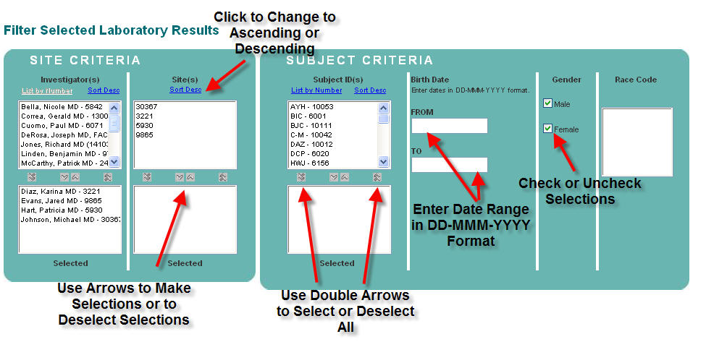
Figure E – Selecting Subject Criteria from the Filter Page

  - Visit Criteria – Visit(s)
By default all visits are selected. To view specific Visit(s), select the Visit(s) by clicking on the appropriate visit(s).
  - Visit Criteria – Collection Date
Enter a range of Collection Dates in DD-MMM-YYYY format in the FROM and TO fields.
  - Test Criteria – Department(s)
By default, all Departments are selected. To view specific Department(s), select the Department(s) by clicking on the appropriate Department. Once a Department(s) has been selected, the Test Name(s) criteria box will populate with the associated Test Names of the chosen Department(s).
  - Test Criteria – Test Name(s)
By default, all Test Name(s) are selected. If a Department(s) was selected then the Test Name(s) for that department will populate. To select specific Test(s), click on the associated Test Name(s).
Test Criteria – Result Flag
By default, all Result Flag(s) are selected (although they are not checked off). To view specific Result Flag(s), check off the appropriate Result Flag(s).
  - Test Criteria – Exclusion(s) (If applicable)
By default, Exclusion(s) are selected (although not highlighted). To view only results that are flagged as Exclusion, click on the Exclusion value.
  - Test Criteria – Toxicity Grade(s) (If applicable)
By default, all Toxicity Grade(s) are selected (although not highlighted). To view only specific Toxicity Grade(s), click on the appropriate Toxicity Grade.
  - Test Criteria – Delta Flag(s) (If applicable)
By default, all Delta Flag(s) are selected (although not highlighted). To view only specific Delta Flag(s), click on the appropriate Delta Flag.
- Test Criteria – Units of Measure
By default, Conventional Units are the units of measure that will display on the screen and on reports. To change the units of measure to Standard International (SI) units, click on the SI Units button.
- Sort By
The Sort By filter option allows the user to select how the report will be sorted. By default, the report is sorted in ascending order by Investigator, then by Subject ID and chronologically by Visit Name. To change the sort order, click on the down arrow and select the field to sort by. Click the appropriate Ascending or Descending button to sort the selected field.
  - Items to Show
All – By default All is selected. Selecting All will result in viewing all results, reviewed and not reviewed.
Reviewed – Selecting Reviewed will result in viewing data that has been marked as reviewed.
Not Reviewed – Selecting Not Reviewed will result in viewing data that has not been marked as reviewed.

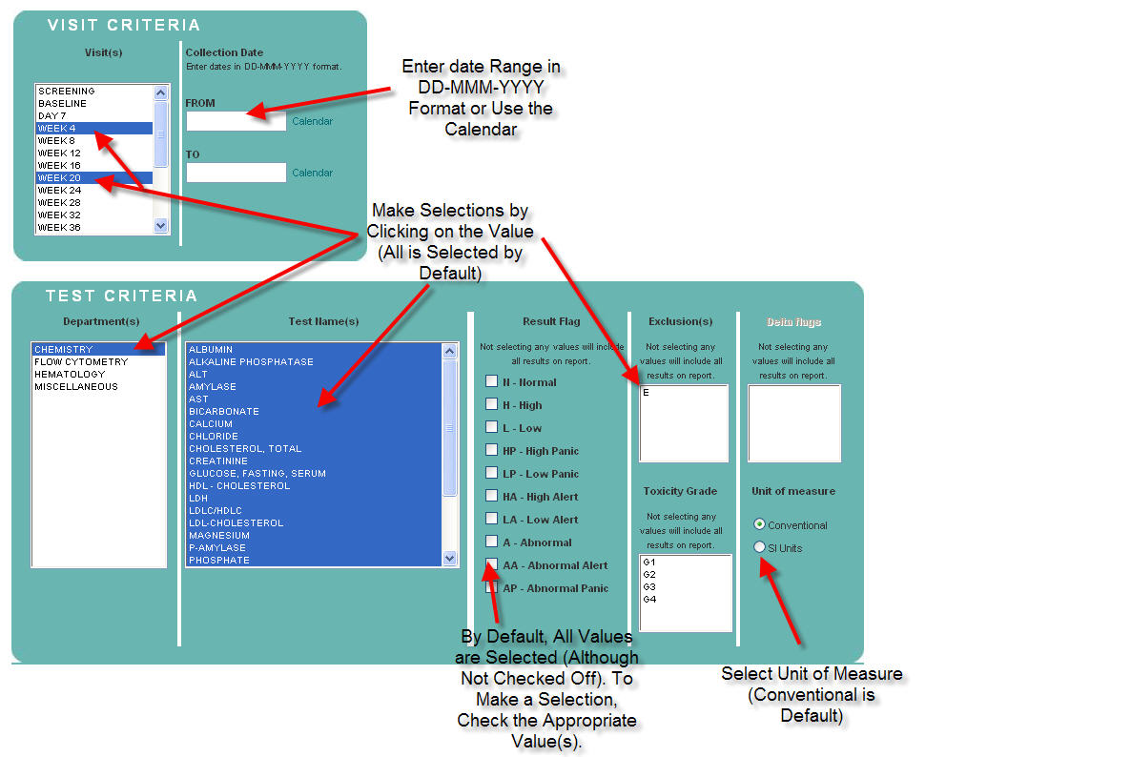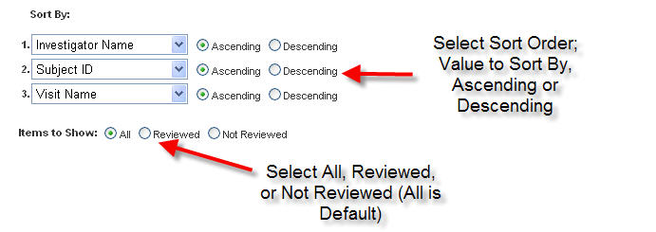
Figure F – Selecting Visit, Test and Sort Order on the Filter Page

Once the filter selections have been made, click on the Show Report button to generate the report. Clicking on Show Report without making any filter selections will result in generating all laboratory results.

To make any changes to the filter selections that were chosen, use the Reset button to reset all of the filter choices that were previously selected. To deselect specific filter choices, use the up arrows to remove the selections, uncheck checked selections, or use the “Ctrl” key and click on the values that you want to deselect.

NOTE: If the report output contains over 65,000 rows of data, a message will generate indicating that only the first 65,000 rows of data will generate on the report. To continue to display the report, click OK, otherwise, use the filters to minimize the output of the report.

- Selected Laboratory Results Report Description
The Selected Laboratory Results report allows the user to view a specifically defined set of laboratory results. With the use of filtering capability, the generated report is customized based on the selected criteria. This report also has drill down capability to view the General Lab and/or the Microbiology Lab Report.

This report includes the following fields, as displayed in Figure G:
  - Investigator Name
  - Site #
  - Subject ID
  - Subject Initials
  - Collection Date
  - Visit Name
  - Accession #
  - Department
  - Test Name
  - Test Results
  - Units
  - Flag

Please note the following about the Selected Laboratory Results report:
- If the subject visit is locked, the word “LOCKED” will appear in place of Test Result, Result Flags, and any associated comment. When the visit becomes unlocked, the result data will become available to view online.
- If the user is blinded to specific test(s), the word “BLINDED” will appear in place of the Test Result, Result Flags, and any associated comment.

To sort the report, click on the Ascending or Descending button and then click a column in the report.

To view a different page on the report, click on the appropriate page number. Page numbers are located at the bottom of the report.

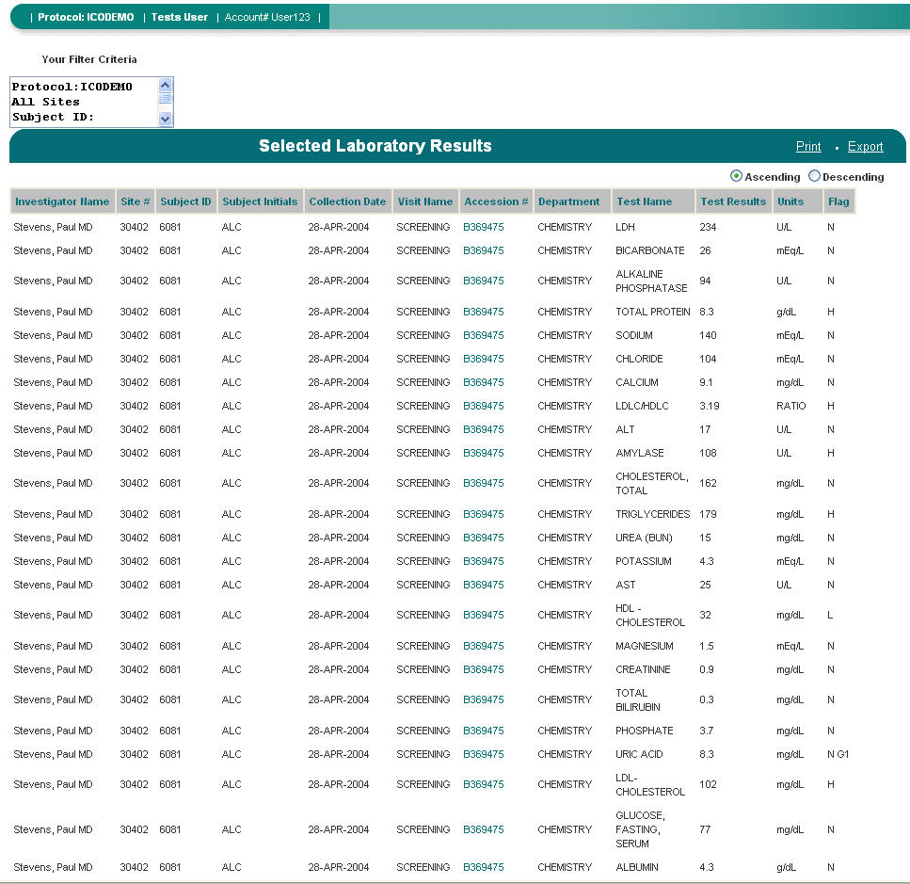
Figure G – Selected Laboratory Results

Hovering Capability
This report has hover capability on the following fields:
- Investigator Name – Displays the investigator name, the investigator address and telephone number.
- Site # - Displays the shipping address.
- Subject ID – Displays the subject ID, subject screen ID, subject initials, gender, date of birth and the race code (If applicable).
- Test Result – If the test result is underlined, there is a test-specific comment associated with the test result. Hovering over the test result will display the test comment.
- Flag – Hovering over the result flag will display the reference range for that specific test.

Drill Down Capability
This report has drill down capability when clicking on the Accession #. Clicking on this filed will generate the General Laboratory and/or Microbiology Report (Please refer to the General Laboratory and Microbiology sections in 7.1.9 & 7.1.10 for report description.) If both a General Laboratory and Microbiology Report exist for the Accession #, then both reports will generate.

Print
Clicking on Print will generate the Print Preview page of the report. From this screen, clicking on the Printer icon will generate the Print dialog box. The report can also be saved as a PDF document from this screen by clicking on the Save icon.

Export
Clicking on Export will open the File Download dialog box. The file can be opened or saved as a Microsoft Excel® comma separated file. If Open is chosen, without saving the report, Microsoft Excel® will auto format the report text. To keep the format the same, choose to Save the report as a .csv file and then import the .csv file into any spreadsheet application.

Your Filter Criteria
The box entitled Your Filter Criteria contains the filter criteria that were selected when the report generated.

7.1.3 Subject Results Trend

- Subject Results Trend Filter Page
  - Subject Criteria – Subject ID(s)
By default, all Subject IDs are listed alphabetically by Subject Initials – Subject ID. To sort by Subject ID click on List by Number. The default sort is ascending. To sort in descending order, click on Sort Desc. This report requires the user to select one Subject ID. Highlight the Subject ID and click on the down arrow to select the highlighted Subject ID.
  - Test Criteria – Department(s)
By default, all Departments are selected. To view specific Department(s), select the Department(s) by clicking on the appropriate Department. Once a Department(s) has been selected, the Test Name(s) criteria box will populate with the associated Test Names of the chosen Department(s).
  - Test Criteria – Test Name(s)
By default, all Test Name(s) are selected. If a Department(s) was selected then the Test Name(s) for that department will populate. To select specific Test(s), click on the associated Test Name(s).
- Test Criteria – Units of Measure
By default, Conventional Units are the units of measure that the report will generate with. To change the units of measure to SI, click on the SI Units button.
- Sort By
The Sort By filter option allows the user to select how the report will be sorted. By default, the report is sorted in ascending order by Department Name, then by Test Name. To change the sort order, click on the down arrow and select the field to sort by. Click the appropriate Ascending or Descending button to sort the selected field.

Once the filter selections have been made, click on the Show Report button to generate the report.

To make any changes to the filter selections that were chosen, use the Reset button to reset all of the filter choices that were previously selected. To deselect specific filter choices, use the up arrows to remove the selections, uncheck checked selections, or use the “Ctrl” key and click on the values that you want to deselect.

- Subject Results Trend Report Description
The Subject Results Trend report allows the user to view data that is presented in a format that can be used to trend subject lab data. This report also has graphing capability, allowing the user to view trend data in a graphical format.

This report includes the following fields, as displayed in Figure H:

- Investigator Name
- Site #
- Subject ID
- Subject Initials
- Test Name
- Protocol-specific visits that the subject has received, excluding unplanned visits

To sort the report, click on the Ascending or Descending button and then click a column in the report.

To view a different page on the report, click on the appropriate page number. Page numbers are located at the bottom of the report.

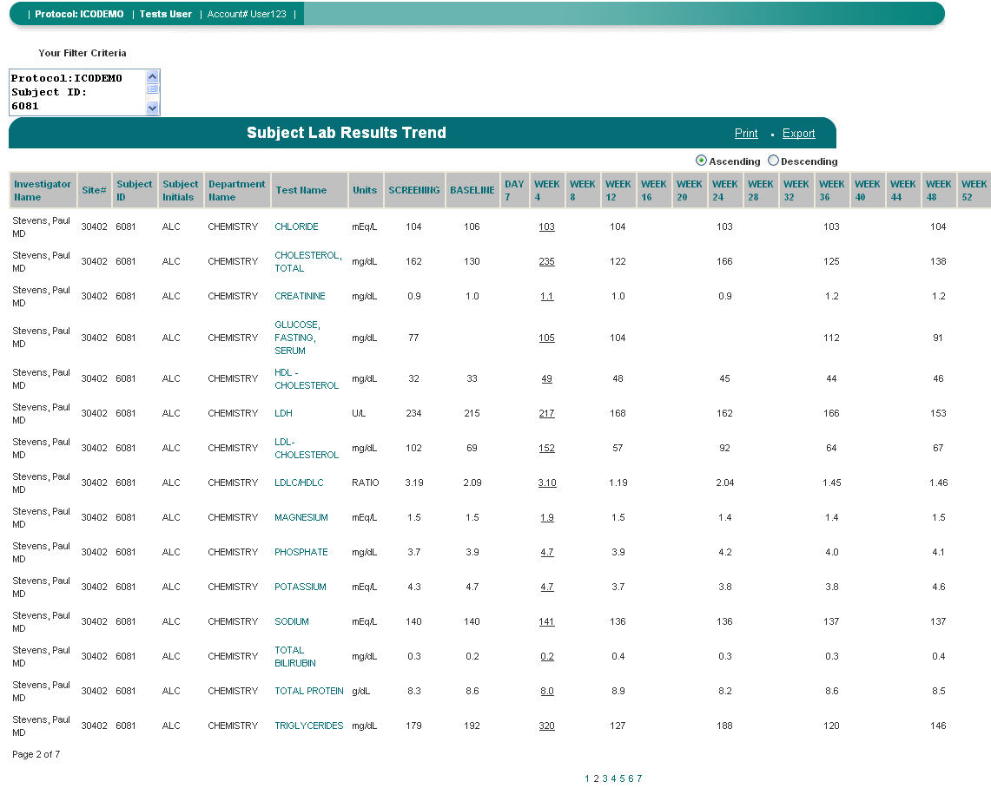
Figure H – Subject Lab Results Trend Report

Hovering Capability
This report has hover capability on the following fields:
- Investigator Name – Displays the investigator name, the investigator address and telephone number.
- Site # - Displays the shipping address.
- Subject ID – Displays the subject ID, subject screen ID, subject initials, gender, date of birth and the race code (If applicable).
- Test Result – If the Test Result is underlined, there is a test-specific comment associated with the test result. Hovering over the test result will display the test comment.

Drill Down Graph Capability
This report has the ability to graph trends for a specific study subject and test. Clicking on the test name will generate the graph of the test results for that subject (To view graphs for the entire or a selected study population, use the Study Trend report). The graph will generate in Microsoft Excel® format (Figure I). The graph can only be displayed. It cannot be printed or exported into a spreadsheet application.

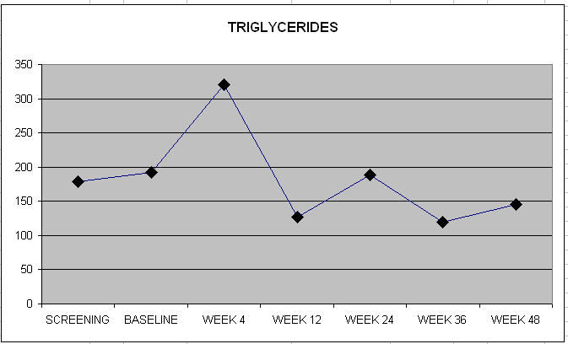
Figure I – A Graph Produced by Clicking on a Test Name in the Subject Trend Report

Print
Clicking on Print will generate the Print Preview page of the report. From this screen, clicking on the Printer icon will generate the Print dialog box. The report can also be saved as a PDF document from this screen by clicking on the Save icon.

NOTE: If the report’s width exceeds the standard 8.5” x 11” landscape page size, the report will generate the appropriate number of pages that is needed to display all data.

Export
Clicking on Export will open the File Download dialog box. The file can be opened or saved as a Microsoft Excel® comma separated file. If Open is chosen, without saving the report, Microsoft Excel® will auto format the report text. To keep the format the same, choose to Save the report as a .csv file and then import the .csv file into any spreadsheet application.

Your Filter Criteria
The box entitled Your Filter Criteria contains the filter criteria that were selected when the report generated.

7.1.4 Study Trend Report

- Study Trend Report Filter Page
  - Site Criteria – Investigator(s)
By default, all Investigators are listed alphabetically by last name then by first name and credentials. To sort by Investigator Number, click on List by Number. The default sort is ascending. To sort in descending order, click on Sort Desc. If a specific selection is not made, the report will default to include all Investigators. To view specific Investigator(s), highlight the Investigator(s) and then click on the down arrow to select the highlighted Investigator(s). Once the Investigator(s) populate in the Selected box, the Site(s) box will populate with the corresponding Site Numbers associated with the selected Investigator(s).
  - Site Criteria – Site(s)
The default sort for sites is in ascending alphanumeric order. To sort in descending order, click on Sort Desc. If a specific selection is not made, the report will default to include all Sites. To view a specific Site(s), highlight the Site(s), and then click on the down arrow to select the highlighted Site(s). Once the Site(s) populate in the Selected box, the Investigator(s) box will populate with the corresponding Investigator Numbers associated with the selected Site(s)
  - Subject Criteria – Birth Date
Enter a range of Birth Dates in DD-MMM-YYYY format in the FROM and TO fields.
  - Subject Criteria – Gender (If applicable)
By default, both Male and Female are selected. To view only Male subjects, uncheck the Female checkbox. To view only Female subjects, uncheck the Male checkbox.
  - Subject Criteria – Race Code(s) (If applicable)
By default, all race codes are selected. To view specific race code(s), select the Race Code(s) by clicking on the appropriate Race Code.
  - Test Criteria – Department(s)
By default, Department is disabled for this report. This report allows only one test to be selected.
  - Test Criteria – Test Name(s)
Select the Test Name of the test by clicking on the Test Name. This report allows only one test to be selected.
  - Test Criteria – Units of Measure
By default, Conventional Units are the units of measure that will display on the screen and on reports. To change the units of measure to Standard International (SI) units, click on the SI Units button.
  - Sort By
The Sort By filter option allows the user to select how the report will be sorted. By default, the report is sorted in ascending order by Investigator, then by Subject ID and chronologically by Visit Name. To change the sort order, click on the down arrow and select the field to sort by. Click the appropriate Ascending or Descending button to sort the selected field.

Once the filter selections have been made, click on the Show Report button to generate the report. Clicking on Show Report without making any filter selections will result in generating all laboratory results.

To make any changes to the filter selections that were chosen, use the Reset button to reset all of the filter choices that were previously selected. To deselect specific filter choices, use the up arrows to remove the selections, uncheck checked selections, or use the “Ctrl” key and click on the values that you want to deselect.

- Study Trend Report Description
The Study Trend report allows the user to view laboratory result data for an entire or selected study population. This report also has graphing capability, allowing the user to view trend data in a graphical format.

This report includes the following fields, as displayed in Figure J:

  - Investigator Name
  - Site #
  - Subject ID
  - Subject Initials
  - Test Name
  - Protocol-specific visits, excluding any unplanned visits

To sort the report, click on the Ascending or Descending button and then click a column in the report.

To view a different page on the report, click on the appropriate page number. Page numbers are located at the bottom of the report.

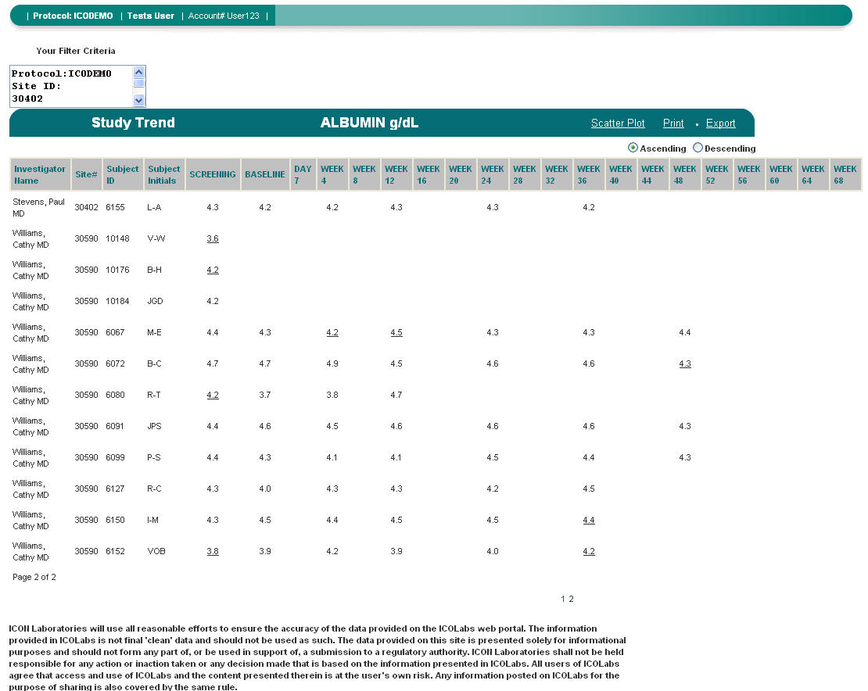
Figure J – A Study Trend Report for Albumin Test Results at a Specific Investigator’s Site

Hovering Capability
This report has hover capability on the following fields:
- Investigator Name – Displays the investigator name, the investigator address and telephone number.
- Site # - Displays the shipping address.
- Subject ID – Displays the subject ID, subject screen ID, subject initials, gender, date of birth and the race code (If applicable).
- Test Result – If the Test Result is underlined, there is a test-specific comment associated with the test result. Hovering over the test result will display the test comment.

Scatter Plot
Clicking on Scatter Plot will generate the scatter plot graph for the selected population and test. (Figure K) The visit names will not appear along the X-axis; however the visit name will appear when hovering over the point in the graph.

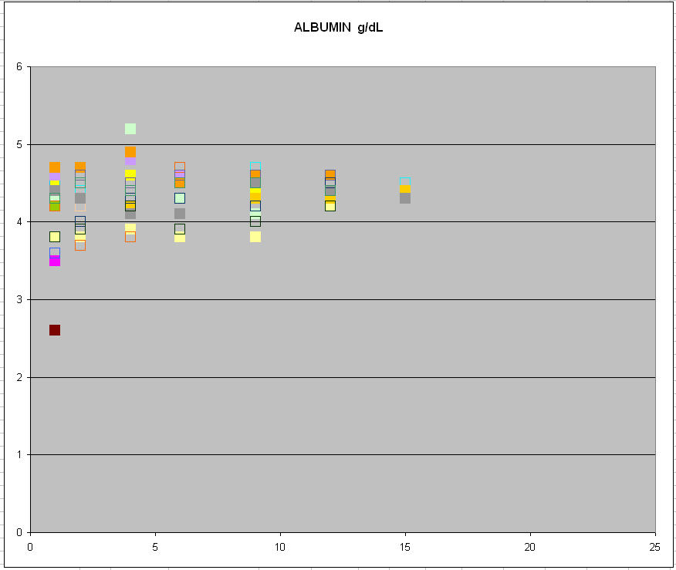
Figure K – A Scatter Plot of Albumin Results for a Selected Study Population

Print
Clicking on Print will generate the Print Preview page of the report. From this screen, clicking on the Printer icon will generate the Print dialog box. The report can also be saved as a PDF document from this screen by clicking on the Save icon.

NOTE: If the report’s width exceeds the standard 8.5” x 11” landscape page size, the report will generate the appropriate number of pages that is needed to display all data.

Export
Clicking on Export will open the File Download dialog box. The file can be opened or saved as a Microsoft Excel® comma separated file. If Open is chosen, without saving the report, Microsoft Excel® will auto format the report text. To keep the format the same, choose to Save the report as a .csv file and then import the .csv file into any spreadsheet application.

Your Filter Criteria
The box entitled Your Filter Criteria contains the filter criteria that were selected when the report generated.

7.1.5 Enrollment Report

- Enrollment Report Filter Page
  - Site Criteria – Investigator(s)
By default, all Investigators are listed alphabetically by last name then by first name and credentials. To sort by Investigator Number, click on List by Number. The default sort is ascending. To sort in descending order, click on Sort Desc. If a specific selection is not made, the report will default to include all Investigators. To view specific Investigator(s), highlight the Investigator(s) and then click on the down arrow to select the highlighted Investigator(s). Once the Investigator(s) populate in the Selected box, the Site(s) box will populate with the corresponding Site Numbers associated with the selected Investigator(s).
  - Site Criteria – Site(s)
The default sort for sites is in ascending alphanumeric order. To sort in descending order, click on Sort Desc. If a specific selection is not made, the report will default to include all Sites. To view a specific Site(s), highlight the Site(s), and then click on the down arrow to select the highlighted Site(s). Once the Site(s) populate in the Selected box, the Investigator(s) box will populate with the corresponding Investigator Numbers associated with the selected Site(s).
- Sort By
The Sort By filter option allows the user to select how the report will be sorted. By default, the report is sorted in ascending order by Investigator Name, then by Site Number. To change the sort order, click on the down arrow and select the field to sort by. Click the appropriate Ascending or Descending button to sort the selected field.

Once the filter selections have been made, click on the Show Report button to generate the report. Clicking on Show Report without making any filter selections will result in generating all laboratory results.

To make any changes to the filter selections that were chosen, use the Reset button to reset all of the filter choices that were previously selected. To deselect specific filter choices, use the up arrows to remove the selections.

  - Enrollment Report Description
The Enrollment report allows the user to view the number of subjects at a site who have completed specific visits. It also provides the user with a grand total of all subjects at specific visits for the entire study. This report also has drill down capability to the Site Activity report.

This report includes the following fields, as displayed in Figure L:

- Investigator Name
- Site #
- Protocol-specific Visit Names
- Total Visit Enrollment
- Grand Total Enrollment at Specific Visits
- Grand total for all visits

To sort the report, click on the Ascending or Descending button and then click a column in the report.

To view a different page on the report, click on the appropriate page number. Page numbers are located at the bottom of the report.

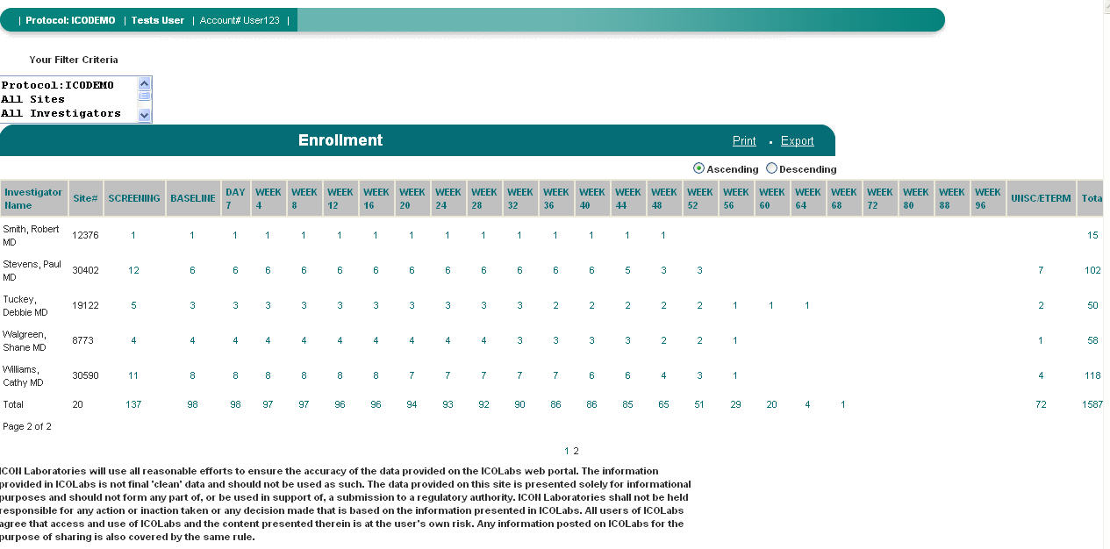
Figure L – An Enrollment Report Displaying Number of Visits Completed at All Study Sites

Hovering Capability
This report has hover capability on the following fields:
- Investigator Name – Displays the investigator name, the investigator address and telephone number.
- Site # - Displays the shipping address.

Drill Down Capability
This report has drill down capability to view the Site Status report. Clicking on a clickable cell that contains a numeric value will drill down to the Site Status report for the specific cell. For Example, clicking on the cell for Site # 002 and Screening, will generate the Site Activity Report for all Site # 002 Screening visits. If the numeric value for that cell is 5, then the report will generate with the 5 subjects that have a Screening visit at Site # 002.

Print
Clicking on Print will generate the Print Preview page of the report. From this screen, clicking on the Printer icon will generate the Print dialog box. The report can also be saved as a PDF document from this screen by clicking on the Save icon.

NOTE: If the report’s width exceeds the standard 8.5” x 11” landscape page size, the report will generate the appropriate number of pages that is needed to display all data.

Export
Clicking on Export will open the File Download dialog box. The file can be opened or saved as a Microsoft Excel® comma separated file. If Open is chosen, without saving the report, Microsoft Excel® will auto format the report text. To keep the format the same, choose to Save the report as a .csv file and then import the .csv file into any spreadsheet application.

Your Filter Criteria
The box entitled Your Filter Criteria contains the filter criteria that were selected when the report generated.

7.1.6 Site Activity Report

- Site Activity Report Filter Page
  - Site Criteria – Investigator(s)
By default, all Investigators are listed alphabetically by last name then by first name and credentials. To sort by Investigator Number, click on List by Number. The default sort is ascending. To sort in descending order, click on Sort Desc. If a specific selection is not made, the report will default to include all Investigators. To view specific Investigator(s), highlight the Investigator(s) and then click on the down arrow to select the highlighted Investigator(s). Once the Investigator(s) populate in the Selected box, the Site(s) box will populate with the corresponding Site Numbers associated with the selected Investigator(s).
  - Site Criteria – Site(s)
The default sort for sites is in ascending alphanumeric order. To sort in descending order, click on Sort Desc. If a specific selection is not made, the report will default to include all Sites. To view a specific Site(s), highlight the Site(s), and then click on the down arrow to select the highlighted Site(s). Once the Site(s) populate in the Selected box, the Investigator(s) box will populate with the corresponding Investigator Numbers associated with the selected Site(s).
  - Subject Criteria – Subject ID(s)
By default, all Subject IDs are listed alphabetically by Subject Initials – Subject ID. To sort by Subject ID click on List by Number. The default sort is ascending. To sort in descending order, click on Sort Desc. If a selection is not made, the report will default to include all Investigators. To view specific Subject(s), highlight the Subject ID(s), and then click on the down arrow.
  - Visit Criteria – Visit(s)
By default all visits are selected. To view specific Visit(s), select the Visit(s) by clicking on the appropriate visit(s).
  - Visit Criteria – Collection Date
Enter a range of Collection Dates in DD-MMM-YYYY format in the FROM and TO fields.
  - Sort By
The Sort By filter option allows the user to select how the report will be sorted. By default, the report is sorted in ascending order by Investigator, then by Subject ID and chronologically by Visit Name. To change the sort order, click on the down arrow and select the field to sort by. Click the appropriate Ascending or Descending button to sort the selected field.

Once the filter selections have been made, click on the Show Report button to generate the report. Clicking on Show Report without making any filter selections will result in generating all laboratory results.

To make any changes to the filter selections that were chosen, use the Reset button to reset all of the filter choices that were previously selected. To deselect specific filter choices, use the up arrows to remove the selections, uncheck checked selections, or use the “Ctrl” key and click on the values that you want to deselect.

- Site Activity Report Description
The Site Activity report generates a summary of the site activity for specific or all sites. When used with filtering, this report allows the user to view activity for specific sites, subjects, visits and/or a range of collection dates. This report will also display if a visit is missed (not received), by displaying Visit Not Received in place of the visit name.

This report includes the following fields, as displayed in Figure M:
  - Site #
  - Investigator Name
  - Subject ID
  - Screen ID
  - Subject Initials]
  - Accession #
  - Visit Name
  - Collection Date

To sort the report, click on the Ascending or Descending button and then click a column in the report.

To view a different page on the report, click on the appropriate page number. Page numbers are located at the bottom of the report.

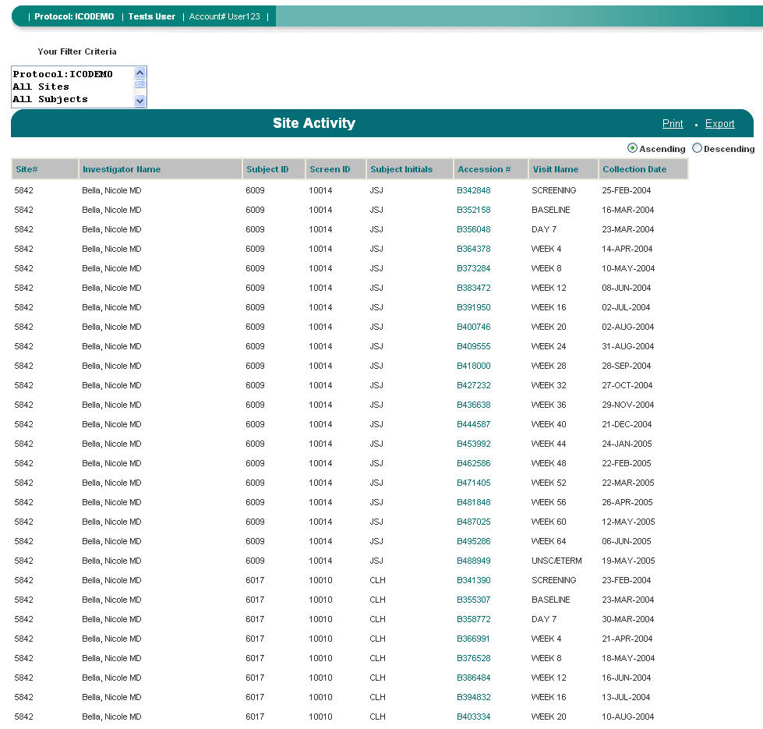
Figure M – A Site Activity Report

Hovering Capability
This report has hover capability on the following fields:
- Investigator Name – Displays the investigator name, the investigator address and telephone number.
- Site # - Displays the shipping address.
- Subject ID – Displays the subject ID, subject screen ID, subject initials, gender, date of birth and the race code (If applicable).

Drill Down Capability
This report has drill down capability when clicking on the Accession #. Clicking on this field will generate the General Lab and/or Micro Report associated with the Accession #. (Please refer to the General Lab and Micro Report in Sections 7.1.9 and 7.1.10 for report description.)

Print
Clicking on Print will generate the Print Preview page of the report. From this screen, clicking on the Printer icon will generate the Print dialog box. The report can also be saved as a PDF document from this screen by clicking on the Save icon.

Export
Clicking on Export will open the File Download dialog box. The file can be opened or saved as a Microsoft Excel® comma separated file. If Open is chosen, without saving the report, Microsoft Excel® will auto format the report text. To keep the format the same, choose to Save the report as a .csv file and then import the .csv file into any spreadsheet application.

Your Filter Criteria
The box entitled Your Filter Criteria contains the filter criteria that were selected when the report generated.

7.1.7 Specimen Storage Management Status Report

- Specimen Storage Management Status Report Filter Page
  - Site Criteria – Investigator(s)
By default, all Investigators are listed alphabetically by last name then by first name and credentials. To sort by Investigator Number, click on List by Number. The default sort is ascending. To sort in descending order, click on Sort Desc. If a specific selection is not made, the report will default to include all Investigators. To view specific Investigator(s), highlight the Investigator(s) and then click on the down arrow to select the highlighted Investigator(s). Once the Investigator(s) populate in the Selected box, the Site(s) box will populate with the corresponding Site Numbers associated with the selected Investigator(s).
  - Site Criteria – Site(s)
The default sort for sites is in ascending alphanumeric order. To sort in descending order, click on Sort Desc. If a specific selection is not made, the report will default to include all Sites. To view a specific Site(s), highlight the Site(s), and then click on the down arrow to select the highlighted Site(s). Once the Site(s) populate in the Selected box, the Investigator(s) box will populate with the corresponding Investigator Numbers associated with the selected Site(s).
  - Subject Criteria – Subject ID(s)
By default, all Subject IDs are listed alphabetically by Subject Initials – Subject ID. To sort by Subject ID click on List by Number. The default sort is ascending. To sort in descending order, click on Sort Desc. If a selection is not made, the report will default to include all Investigators. To view specific Subject(s), highlight the Subject ID(s), and then click on the down arrow.
  - Visit Criteria – Visit(s)
By default all visits are selected. To view specific Visit(s), select the Visit(s) by clicking on the appropriate visit(s).
  - Storage Criteria – Container Names
By default, all container names are selected. To select and view a specific Container Name(s), click on the appropriate Container Name.
  - Storage Criteria – Status
By default, all statuses are selected. To view a specific Status, select the Status by clicking on the appropriate status.
    - In Storage – The sample is stored at ICON Laboratories.
    - Shipped Out – The sample has been shipped out.
    - Transferred Out – The sample has been transferred out, but ICON expects to store the sample in again.
- Sort By
The Sort By filter option allows the user to select how the report will be sorted. By default, the report is sorted in ascending order by Investigator, then by Subject ID and chronologically by Visit Name. To change the sort order, click on the down arrow and select the field to sort by. Click the appropriate Ascending or Descending button to sort the selected field.

Once the filter selections have been made, click on the Show Report button to generate the report. Clicking on Show Report without making any filter selections will result in generating all Specimen Storage samples.

To make any changes to the filter selections that were chosen, use the Reset button to reset all of the filter choices that were previously selected. To deselect specific filter choices, use the up arrows to remove the selections, uncheck checked selections, or use the “Ctrl” key and click on the values that you want to deselect.

- Specimen Storage Management Status Report Description
The Specimen Storage Management Status report allows the user to view the specimens that are being stored at ICON Laboratories. The user can view all samples that are stored, the type of samples and if or when the samples were shipped. This report includes the following fields, as displayed in Figure N:
- Investigator Name
- Site #
- Subject ID
- Subject Initials
- Accession #
- Visit Name
- Bar Code
- Container Name
- Shipment #
- Current Status
- Ship To
- Transaction Date

To sort the report, click on the Ascending or Descending button and then click a column in the report.

To view a different page on the report, click on the appropriate page number. Page numbers are located at the bottom of the report.

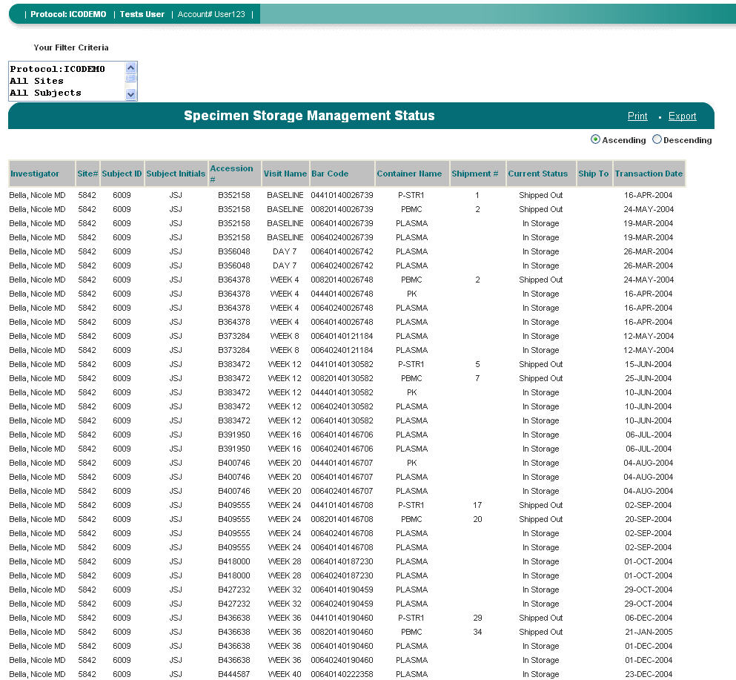
Figure N – A Specimen Storage Management Report

Hovering Capability
This report has hover capability on the following fields:
- Investigator Name – Displays the investigator name, the investigator address and telephone number.
- Site # - Displays the shipping address.
- Subject ID – Displays the subject ID, subject screen ID, subject initials, gender, date of birth and the race code (If applicable).

Print
Clicking on Print will generate the Print Preview page of the report. From this screen, clicking on the Printer icon will generate the Print dialog box. The report can also be saved as a PDF document from this screen by clicking on the Save icon.

Export
Clicking on Export will open the File Download dialog box. The file can be opened or saved as a Microsoft Excel® comma separated file. If Open is chosen, without saving the report, Microsoft Excel® will auto format the report text. To keep the format the same, choose to Save the report as a .csv file and then import the .csv file into any spreadsheet application.

Your Filter Criteria
The box entitled Your Filter Criteria contains the filter criteria that were selected when the report generated.

7.1.8 Kit Inventory Report

- Kit Inventory Report Filter Page
  - Site Criteria – Investigator(s)
By default, all Investigators are listed alphabetically by last name then by first name and credentials. To sort by Investigator Number, click on List by Number. The default sort is ascending. To sort in descending order, click on Sort Desc. If a specific selection is not made, the report will default to include all Investigators. To view specific Investigator(s), highlight the Investigator(s) and then click on the down arrow to select the highlighted Investigator(s). Once the Investigator(s) populate in the Selected box, the Site(s) box will populate with the corresponding Site Numbers associated with the selected Investigator(s).
  - Site Criteria – Site(s)
The default sort for sites is in ascending alphanumeric order. To sort in descending order, click on Sort Desc. If a specific selection is not made, the report will default to include all Sites. To view a specific Site(s), highlight the Site(s), and then click on the down arrow to select the highlighted Site(s). Once the Site(s) populate in the Selected box, the Investigator(s) box will populate with the corresponding Investigator Numbers associated with the selected Site(s).
  - Sort By
The Sort By filter option allows the user to select how the report will be sorted. By default, the report is sorted in ascending order by Investigator, then by Visit Type. To change the sort order, click on the down arrow and select the field to sort by. Click the appropriate Ascending or Descending button to sort the selected field.

Once the filter selections have been made, click on the Show Report button to generate the report. Clicking on Show Report without making any filter selections will result in generating all site kit inventory.

To make any changes to the filter selections that were chosen, use the Reset button to reset all of the filter choices that were previously selected. To deselect specific filter choices, use the up arrows to remove the selections.

- Kit Inventory Report Description
The Kit Inventory report allows the user to view the inventory of all kits for all or specific sites. The user will be able to determine the number of visit-specific kits available at each investigator site. This report also has drill down capability to view the Kit Inventory Detail report that lists the kits and their expiration date.

This report includes the following fields, as displayed in Figure O:
  - Investigator Name
  - Site #
  - Kit Type
  - Total Sent
  - Total Returned to ICON Central Laboratories
  - Total Expired
  - Total Expiring in 0 – 30 Days
  - Total Expiring in 31 to 60 days
  - Total Available

NOTE: Statistics provided on the Kit Inventory Report are based upon ICON Laboratories' records of kits sent to and received from each investigator site. Please note that a number of factors can affect the accuracy of the information provided on this report, including:

- Use of kits by site personnel to obtain replacement supplies, thereby rendering the kit unusable;
- Site use of the wrong kit for a visit;
- Site use of kits for testing outside the protocol;
- Kits damaged or lost in shipping;
- Kits destroyed/discarded on site for any reason;
- If a protocol is configured to receive GenKits, the report will display Total Sent, however, it will not calculate Total Returned, and therefore Total Available will not be accurate. Please contact your ICON Project Manager for this information.

To sort the report, click on the Ascending or Descending button and then click a column in the report.

To view a different page on the report, click on the appropriate page number. Page numbers are located at the bottom of the report.

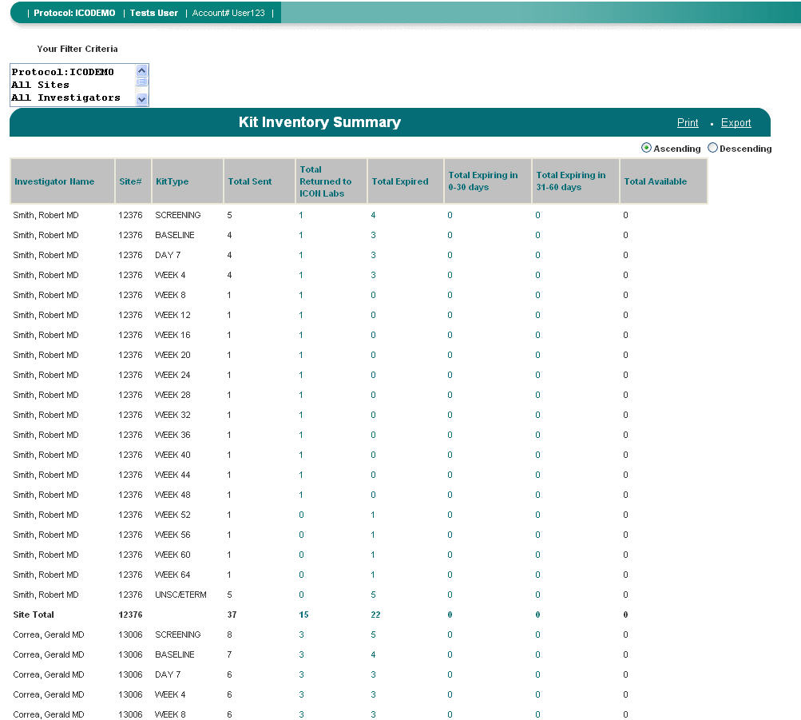
Figure O - A Kit Inventory Report

Hovering Capability
This report has hover capability on the following fields:
- Investigator Name – Displays the investigator name, the investigator address and telephone number.
- Site # - Displays the shipping address.

Drill Down Capability
This report has drill down capability to view the Kit Inventory Detail report. This report lists the Kit Type, Lab Code and Expiration Date. Clicking on a clickable cell that contains a numeric value will generate the Kit Inventory Detail report. For example, clicking on a cell for Site # 123, Visit 1, Total Expired cell will generate the Kit Inventory Detail report listing all expired Visit 1 kits for that specific site. (Figure M)
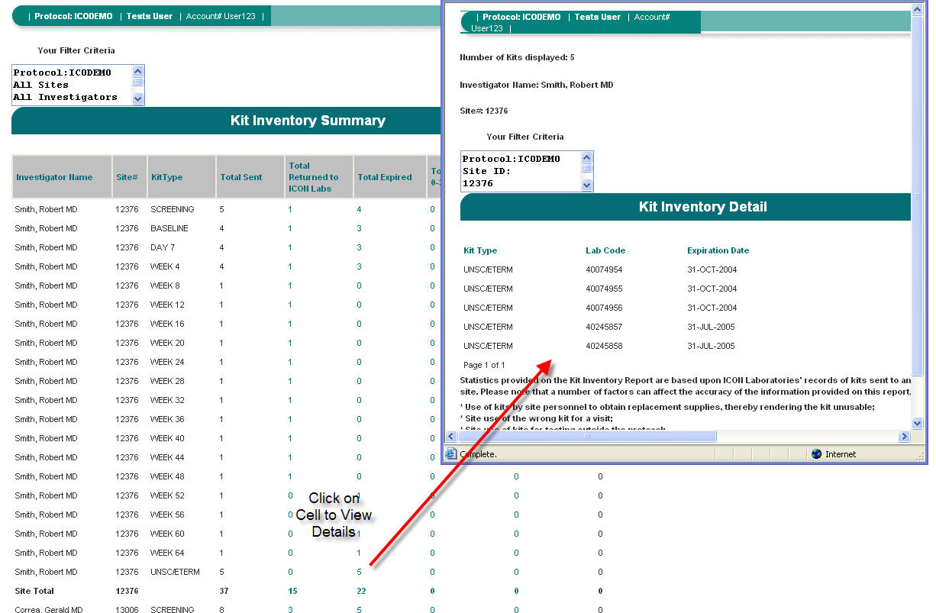
Figure P – Clicking on a Cell Produces A Kit Inventory Detail Report

Print
Clicking on Print will generate the Print Preview page of the report. From this screen, clicking on the Printer icon will generate the Print dialog box. The report can also be saved as a PDF document from this screen by clicking on the Save icon.

Export
Clicking on Export will open the File Download dialog box. The file can be opened or saved as a Microsoft Excel® comma separated file. If Open is chosen, without saving the report, Microsoft Excel® will auto format the report text. To keep the format the same, choose to Save the report as a .csv file and then import the .csv file into any spreadsheet application.

Your Filter Criteria
The box entitled Your Filter Criteria contains the filter criteria that were selected when the report generated.

7.1.9 General Laboratory Report

The General Laboratory Report (Figure P) can be accessed through standard reports containing the Accession # field (with the exception of the Specimen Storage Management report). The General Lab Report contains data that are formatted to resemble the actual Lab Report that is faxed to the sites from ICON Central Laboratories. This report is not intended to replace the actual lab report, but rather to display data in the same format as the Lab Report received by the site.

NOTE: Clicking on Accession # will generate the associated General and / or Microbiology report(s) with the exception of the New/Amended Laboratory Results report that has one column for General Lab report and one for the Microbiology report.
The following standard reports contain drill down capability to the General Laboratory Report:

- New/Amended Laboratory Results
- Selected Laboratory Results
- Site Activity

If the user chooses to, this report can be marked as reviewed by clicking on Click Here to Mark Report as Reviewed. When clicked, a message will appear indicating that the Accession # has been reviewed. To continue, click OK. This action will close the report window and mark the report as “reviewed”. If the report was previously marked as “reviewed,” the Click Here to Mark Report as Reviewed option will not display.

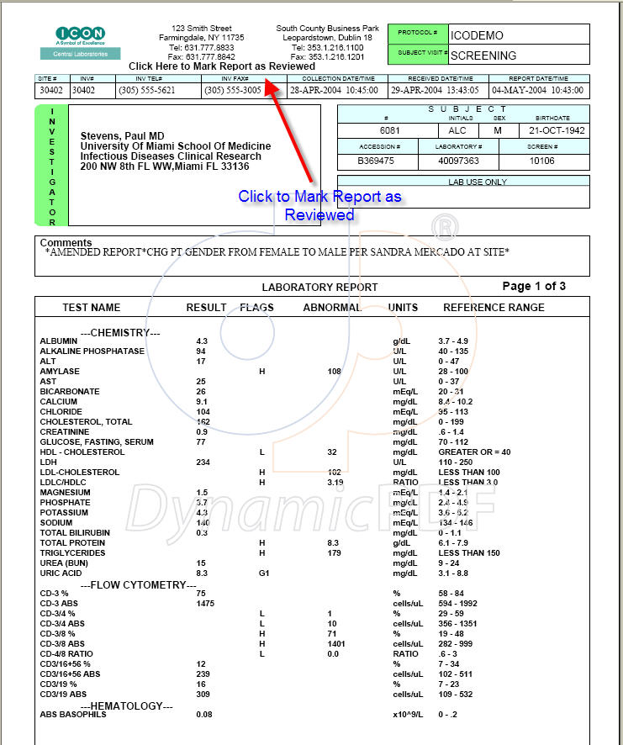
Figure P – Example General Laboratory Report

7.1.10 Microbiology Laboratory Report

The Microbiology Laboratory Report (Figure Q) can be accessed through standard reports containing the Accession # field. The Microbiology Report contains data that are formatted to resemble the actual Microbiology Report that is faxed to the sites from ICON Central Laboratories. This report is not intended to replace the actual microbiology report, but rather to display data in the same format as the Lab Report received by the site.

NOTE: Clicking on Accession # will generate the associated General and / or Microbiology report(s) with the exception of the New/Amended Laboratory Results report that has one column for General Lab report and one for the Microbiology report.

The following standard reports contain drill down capability to the Microbiology Report:
- New/Amended Laboratory Results
- Selected Laboratory Results
- Site Activity

If the user chooses to, this report can be marked as reviewed by clicking on Click Here to Mark Report as Reviewed. When clicked, a message will appear indicating that the Accession # has been reviewed. To continue, click OK. This action will close the report window and mark the report as “reviewed”. If the report was previously marked as “reviewed,” the Click Here to Mark Report as Reviewed option will not display.

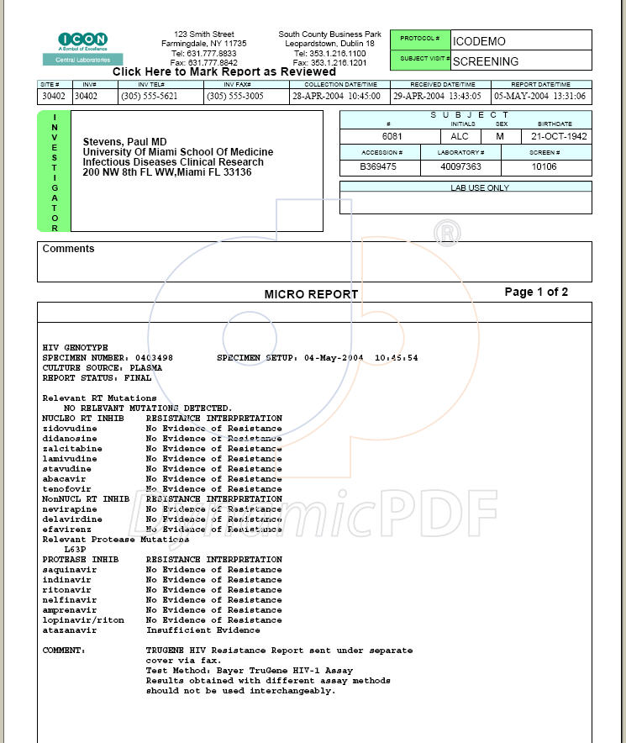
Figure Q –Example of a Microbiology Report

8.0 Custom Searches

ICOLabs has the capability to save a standard report applying user’s filter selections. Once a user selects a standard report and applies filter criteria to the report, the report generates. Once the report has generated, the filter page for the report will enable the “Save Filter as Custom Search” field (Figure R). To save the search criteria, enter the desired name of the report and click on “Save Filter as Custom Search”. The custom search will save and can be accessed in the Custom Search drop down bar.

Please note the following about Custom Searches:
- Custom Searches only save the filter criteria of a standard report, not the actual report data.
- There is no limit to the number of Custom Searches that can be saved.
- Custom Searches must have a unique name. If a duplicate name is entered, the user will be prompted to select a different name.
- Custom Searches can be renamed or deleted from the Manage Custom Searches screen.

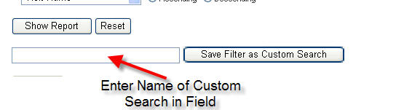
Figure R – Saving A Custom Search

9.0 Manage Profile

Users have the ability to customize their ICONtrol Panel and change their password through the Manage Profile screen (Figure S). To access this screen, click on the Manage Profile link.

To change the password, click on the Change User Password button. If this is selected, the Password Change screen will appear. Enter the new password twice and click on Update Password.

To configure Favorite Reports;
- In the Favorites section a custom search can be set as a favorite report by choosing the custom search from the drop down bar.
- Up to 5 custom searches can be set up as Favorite Reports. The number located next to the Favorite Search represents the order of the reports appearing on the ICONtrol Panel from left to right.
- Once satisfied with the selection(s), click on Save Changes to update the Favorite Reports.

To configure Key Indicators:
- The user can set Key Indicators by selecting the Key Indicators from the drop down bars.
- Up to four Key Indicators can be selected. The number located next to the Key Indicator represents the order in which the Key Indicators appear on the ICONtrol Panel, from top to bottom.
- Once satisfied with the selection(s), click on Save Changes to update the Key Indicators.

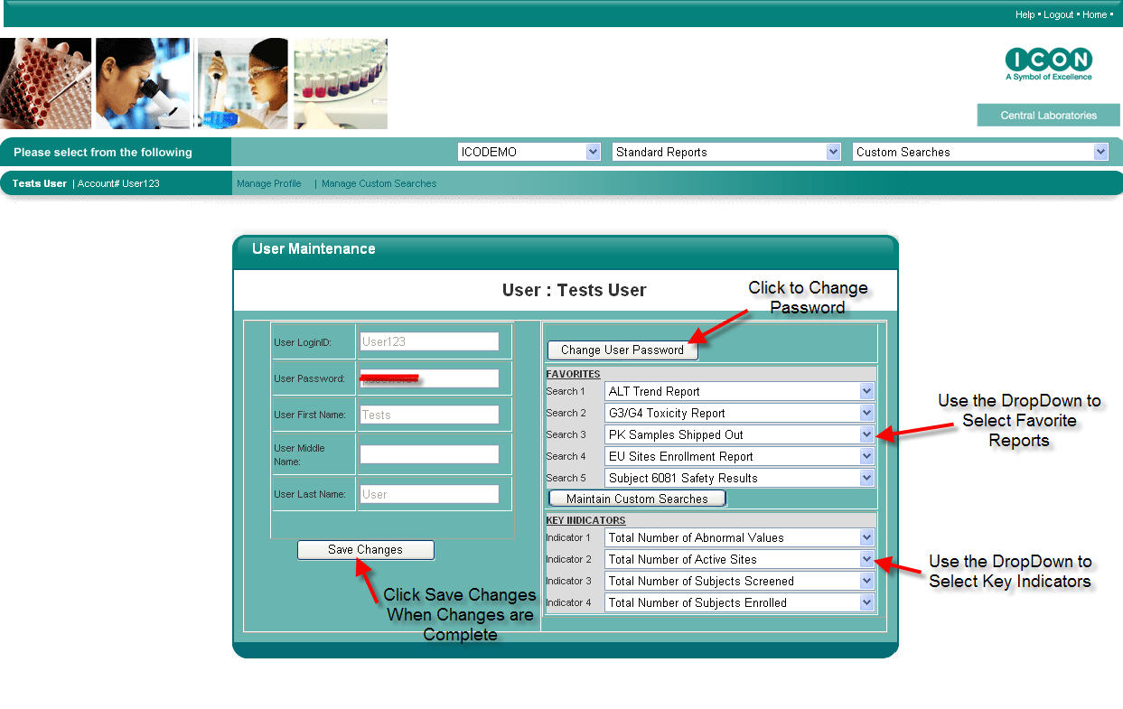
Figure S – Changing the User Profile

- Manage Custom Searches

The Manage Custom Searches screen (Figure T) allows the user to rename, delete and/or change the order of their Custom Search listing. To access this screen, select a protocol and click on the Manage Custom Searches link. The screen will populate with the list of Custom Searches that the user has created for the selected protocol.

To change the order of the Custom Search listing, click on Custom Search and use the arrows to move the Custom Searches up or down.

To rename a Custom Search, click on specific Custom Search to be renamed, and then type the new desired name of the Custom Report in the space above the Save Rename button. Once satisfied with the Custom Search name, click on the Save Rename button.

To delete a Custom Search, click on the specific Custom Search to be deleted and then click on the Delete button.

Once all changes have been made, click on Close button to return to the Home Page.

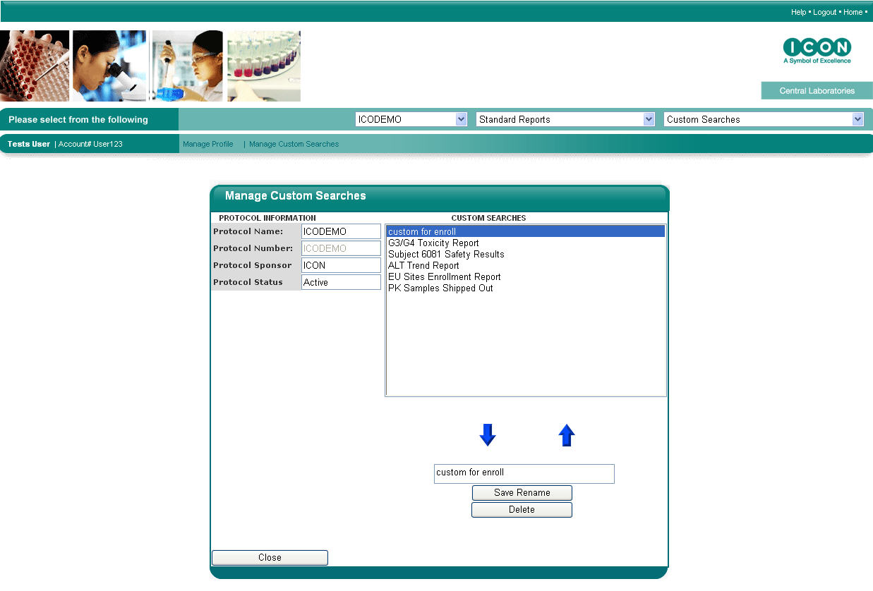
Figure T – Modifying and Deleting Custom Searches

11.0 ICONtrol Panel

The ICONtrol Panel (Figure B) is a customizable home page that allows the user to have quick and easy access to the most pertinent study data for each assigned protocol.

The ICONtrol Panel consists of five favorite reports, four key indicators, and the list of standard reports.

11.1 Favorite Reports
Favorite Reports are Custom Searches that the user has defined through the Manage Profile feature. To set up the Favorite Reports:

- Choose the protocol from the protocol drop down bar.
- Click on the Manage Profile link.
- In the Favorites section a custom search can be set as a favorite report by choosing the custom search from the drop down bar.
- Up to 5 custom searches can be set up as Favorite Reports. The number located next to the Favorite Search represents the order of the reports appearing on the ICONtrol Panel from left to right.
- Once selections have been made, click on Save Changes to update the Favorite Reports and then click on Home to return to the ICONtrol Panel.

11.2 Key Indicators
Key Indicators provide summary information for a specific protocol. The user can choose up to four Key Indicators to display on the ICONtrol Panel. The user can choose their Key Indicators from the Manage Profile page. The following are the Key Indicators that are available:

- Total Number of Abnormal Results – This Key Indicator will display the total number of Abnormal results for the entire study population.
- Total Number of Active Sites – This Key Indicator will display the total number of active sites. A site is considered “active” when ICON Central Laboratories has received specimens for at least one subject visit.
- Total Number of Delta Values – This Key Indicator will display the total number of results that have a Delta Flag. (If applicable to protocol)
- Total Number of Exclusions – This Key Indicator will display the total number of results that have been flagged as exclusions. (If applicable to protocol)
- Total Number of New/Amended Laboratory Reports – This Key Indicator will display the number of New/Amended Laboratory reports that are in the queue awaiting review.
- Total Number of Newly Activated Sites in the Past 7 Days – This Key Indicator will display the number of sites that have their first subject visit within 7 days.
- Total Number of Panic Values – This Key Indicator will display the number of results that have a panic result flag. (If applicable to protocol)
- Total Number of Subjects Enrolled – This Key Indicator will display the number of Subjects that have been enrolled. This number is based on the number of subjects that have had the visit that is specified as the enrollment visit as per the ICOLabs CLW. (If applicable to protocol)
- Total Number of Subjects Screened - This Key Indicator will display the number of study subjects that have been screened. This number is based on the number of subjects that have completed the visit that is specified as the “screening visit,” per the ICOLabs CLW. (If applicable to protocol)

To select the Key Indicators:
- Choose the protocol from the protocol drop down bar.
- Click on the Manage Profile link.
- Set the Key Indicators by selecting the specific Key Indicators from the drop down bars.
- Up to four Key Indicators can be selected. The number located next to Indicator, represents the order of the Key Indicators appearing on the ICONtrol Panel, from left to right.
- Once selections have been made, click on “Save Changes” to update the Key Indicators and then click on Home to return to the ICONtrol Panel.
12.0 Frequently Asked Questions

Q: How do I get an ICOLabs account?

A: ICON Central Laboratories’ Remote Data Access Services (RDAS) Department will create an ICOLabs account, upon receipt of a completed ICOLabs CLW. Please contact your ICON Laboratories Project Manager to request an account.

Q: Do I need to download any applications to my PC?

A: No. ICOLabs was designed to be completely web based. Consequently, the only requirement is the ability to access the Internet. However, in order to export reports, Microsoft Excel® must be installed since the export is in Microsoft Excel® format.

Q: How can I view subject results?

A: Subject results can be viewed in many different formats using the standard reports. To generate one of the standard reports, choose the report from the Standard Report drop down bar or from the ICONtrol Panel.

Q: I logged into ICOLabs, but everything is disabled. What's wrong?

A: If your account is assigned to more than one protocol, then you must select the protocol to work with from the Select Protocol. Once a protocol has been selected, then the ICONtrol Panel will become enabled.

Q: How can I review new data?

A: New data can be reviewed by generating the New/Amended Laboratory Results report, or by using the Selected Laboratory Results report and selecting “Not Reviewed” on the report filter page.

Q: How can I change my Favorite Reports and Key Indicators?

A: Favorite Reports and Key Indicators can be changed in the Manage Profile screen. To access this screen, click on the Manage Profile link.

Q: I created a custom search and would like other users on my team to use this report. How can I do that?

A: Your ICON Central Laboratories RDAS Specialist can create a custom search that is available to all users. Please contact the RDAS Specialist to discuss the report that you would like created for team-wide access.

Q: How can I change my password?

A: Passwords can be changed from the Manage Profile screen. To access this screen, click on the Manage Profile link and select “Change Password”. You will be prompted to change your password.

Q: What does LOCKED mean in my reports?

A: When a subject visit is received with missing or discrepant demographic or collection information, ICON Central Laboratories "locks" the visit. This action prevents reporting to the site and inclusion of the questionable data in data transmissions to the client until there is resolution to the missing or discrepant information. All testing is performed as usual, unless the missing information prevents the proper testing from being performed. In addition, any panic, exclusion, and other client-defined abnormal values requiring site notification are called to the site as usual and without delay. However, no lab report is faxed or mailed to the site until the missing or discrepant information is resolved.

Q: How can I contact support?

A: ICOLabs Support can be contacted via email at icolabssupport@iconlabinc.com or by phone 631.306.9781. Support hours are Monday – Friday, 9:00 am EST – 5:30 pm EST.

Q: I forgot my password and/or my account is locked, who do I contact to unlock it?

A: Contact ICOLabs support via email at icolabssupport@iconlabinc.com or by phone 631.306.9781. Support hours are Monday – Friday, 9:00 am EST – 5:30 pm EST.

________________

Trademark Information
ICOLabs™ is a trademark of ICON Central Laboratories, Inc.
Windows® is a registered trademark of Microsoft Corporation
Pentium® is a registered trademark of Intel Corporation
Internet Explorer® is a registered trademark of Microsoft Corporation
Macintosh® is a registered trademark of Apple Computer, Inc.
Excel® is a registered trademark of Microsoft Corporation

